PICTURE RETAKE DAY IS COMING



**For picture retakes , original pictures must be returned at time of retake.**

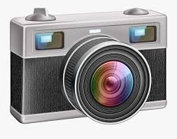

**DATES:**

**IN SCHOOL STUDENTS**

**TUESDAY,**

**JANUARY 26, 2021**

**VIRTUAL/REMOTE STUDENTS**

**FRIDAY,**

**JANUARY 29, 2021**

**Beginning**

**10:00 a.m.**

**Telford Street Entrance**

**Only**